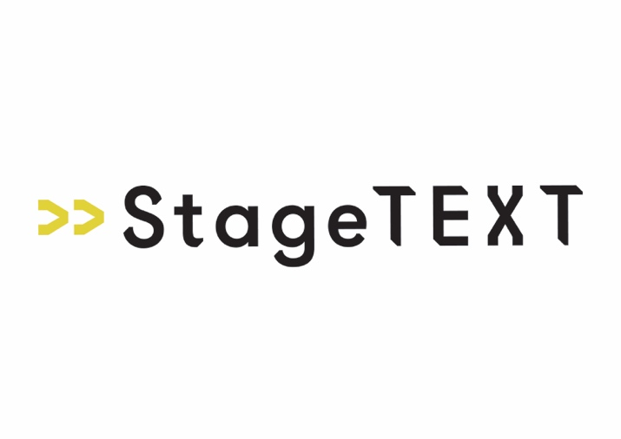
Application Form

Post applied for: Project Delivery Manager (Maternity Cover) - 1-year fixed term contract

Personal Details
Surname: | Other Names:
Address:
Home Telephone: | Work Telephone:
Email: | Mobile Telephone:

Most recent employment (paid or unpaid)
Name of Organisation: | Job Title:
Date of Appointment: | Current or final salary/wage:
Period of notice required: | Leaving date if now not working:
Give a brief outline of your responsibilities:

Education, Training & Professional Qualifications
School, University, etc: | Qualifications Obtained:

Previous Employment (paid or unpaid)
Name & address of previous employers | Job Title | Brief description of responsibilities | Time in post
Continue on another piece of paper if necessary
Experience, skills, and interests
Using the person specification as a guide, please outline how your skills and experience meet the criteria for the post (please try to limit your answer to two pages).
Referees

Please give the name and address of two referees. At least one referee should be your present or most recent employer (if applicable).
Name: |  | Name:
Address: |  | Address:
Telephone: |  | Telephone:
Email: |  | Email:
Occupation: |  | Occupation:
May we request a reference? |  | May we request a reference?
- At any time  - Only after offer of employment |  | - At any time  - Only after offer of employment
- In order to comply with the Immigration Act 1996 we are required to see proof of your right to work in the UK. This will be requested once an offer has been made. However, if you require a work permit to work in the UK please indicate by ticking this box.

Declaration
To the best of my knowledge the information on this application form and equal opportunities monitoring for is correct.
Signature: | Date:

Please return the completed application form to liz@stagetext.org putting Application for ‘Project Delivery Manager’ in the subject line. No CVs will be considered.

Please complete the online equal opportunities form here: Equality and Diversity Monitoring Form Survey

Closing date: Midnight Sunday 9th August

Interviews: Week commencing 24th August 2026 with second interview offer by the end of week commencing 31st August 2026.

Must be available to commence work from: 12th October

